Project Report

|  |  |
| --- | --- |
| **Topics** | **Page** |
|  |  |
| Indexing | 1 |
|  |  |
| Project Title | 2 |
|  |  |
| Team Members | 2 |
|  |  |
| Introduction | 3 |
|  |  |
| Objective Of System | 3 |
|  |  |
| Knowledge Acquisition | 3 |
|  |  |
| Knowledge design & Engineering | 4 |
|  |  |
| User Interface | 6 |
|  |  |
| Implementation | 6 |
|  |  |
| Project Task Management | 7 |
|  |  |

PROJECT TITLE

**Disease Prognosis Expert System**

PROJECT MEMBERS

|  |  |
| --- | --- |
| ***MEMBER NAME*** | ***STUDENT ID*** |
| Vaibhav Jain | 100837042 |
| Smriti Raina | 100830255 |
| Vaibhavi Thakkar | 100833169 |
| Shrutika Raut | 100844617 |

INTRODUCTION

Advancement in the medical field has helped both doctor and patient to fight against many severe diseases. However, there are many real time cases where though providing symptoms patients need to wait for a report and to overcome this, the provided Expert System will help to detect diagnosis based on symptoms provided.

Task and Purpose of the Expert System

The purpose of this expert system is to support the diagnosis process of physicians. It considers facts and symptoms to provide diagnosis. This is a Rule Based Expert System that helps the user to detect which disease they have by analyzing their provided symptoms. In this system we have added a couple of diseases to analyze.

Knowledge Sources & Knowledge Acquisition

The system is designed based on the data of various diseases, its symptoms, and treatments. Nearly 15 diseases were analyzed for training and testing of the system. The data was segregated into separate text files containing disease details, symptoms and treatments and further mapped to each disease.

**Source of Data:**

[*https://www.webmd.com/a-to-z-guides/common-topics*](https://www.webmd.com/a-to-z-guides/common-topics)

[*https://www.mayoclinic.org/diseases-conditions*](https://www.mayoclinic.org/diseases-conditions)

Knowledge Design & Engineering

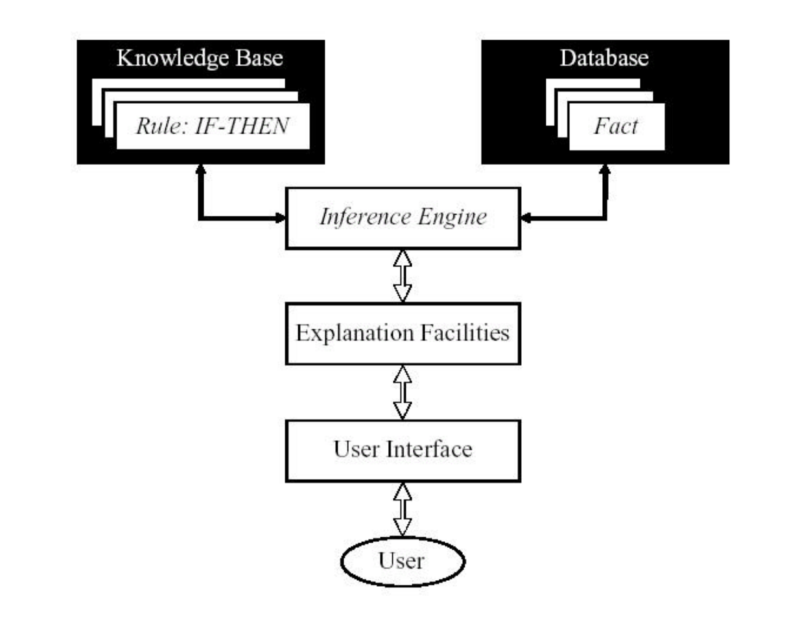

The goal of designing an expert system is to solve a complex problem by reasoning with knowledge rather than by conventional procedural codes. The design of a system consists of consists user interface, data management layer (knowledge base) and application processing (inference engine).

**User interface** interacts to system user to get input data and to receive system generated output.

**Data management** layer includes designing the knowledge base containing the rules and facts about various diseases.

**Application processing** layer is concerned with input transformation, rule activation weight calculation, and the aggregation of the rules.

Inference Procedures

To diagnose the diseases, it is necessary to get its values of the signs and symptoms, collected from experts. These values considered as the input values of the expert system. Basically, these signs and symptoms considered as the antecedent attributes of a rule. Each input value needs to be distributed over the referential values of an antecedent attribute to demonstrate what amount of this input value match with each of the referential value. The referential values of each antecedent attribute may by “Severe”, “Mild” and “No”, which are similar to the signs and symptoms of the diseases as express by the experts in terms of these linguistic terms.

This factual knowledge is used to to derive logical conclusions. Here the system uses forward chaining to search from the rules until the rule is found where the if-clause is known to be true. When such a rule is found, the process may conclude or forward to the then-clause for further inference. The process is iterated until a goal is reached.

Knowledgebase Construction

Decision tree which has been developed using knowledge acquisition.

The tree represents a multilevel hierarchical structure of the knowledge base.

The leaf nodes become the antecedent attributes of a rule and the parent node becomes its consequent attribute.

|  |
| --- |
| *A12 = Asthma* |
| *A11 = Chest Pain* |
| *A10 = Cough* |
| *A9 = Restlessness* |
| *A8 = Sore Throat* |
| *A... = ….* |
| *A1 = Fever* |

This rule base consists of 11 antecedent attributes namely A1, A2, A3… A11. Each attribute has three referential values, namely severe (S), mild (M) and no symptoms (N).

So, the belief rule is written as,

R1: *If Chest Pain is Severe AND Cough is Severe AND Restlessness is Mild AND …*

*THEN { Disease identified is Asthma }*

User Interface

Interacts to system user to get input data and to receive system generated output.

The system is designed to accept values for pre-defined set of symptoms. The value ranges from Severe, Mild and No symptoms.

The input values are passed as a referential values and system generates the output based on the rules defined.

The output from system is the probable Disease, it’s description and possible treatments.

Implementation

**Programming Language:** Python

**Featured Library:** Experta

**Data:** Text files

**IDE:** Pycharm, Visual Studio, Anaconda (Python supported IDE)

**Repository**: Github

Project Task Management

|  |  |
| --- | --- |
| **Team Members** | **Task** |
| Smriti Raina | Knowledge acquisition and implementation |
| Vaibhav Jain | Module integration and driver function implementation |
| Vaibhavi Thakkar | Documentation & framing user inputs |
| Shrutika Raut | Rule defining and implementation |